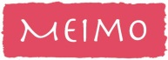
Kids Menu
Starters;
Garlic Bread
Mains;
Sausage & Straw Fries
Mini Cheese Burger & Fries
Penne Pasta
Served with a choice of cheese, Bolognese or napolitana sauce
Dessert;
Ice cream
Vanilla/ Strawberry/ Chocolate
Drinks;
Orange or Blackcurrant Squash/Milk
Any 2 courses and drink - £4.95
Additional course - £1.50

